**Lab Assignment 1**

**Mobile application development**

**CS 5590**

-Saidu Babu Dosapati

-ID: 14

**Aim:**

The aim of the assignment is to build an application where we build/design this application in a way that the user can login or register through his existing google or Facebook account

**Objective:**

We create a login page and also a registration page for the new user while signing up

We then proceed to implement the login using OAuthentication via google or facebook

When the user clicks on register page, the application is directed to the page where the user is asked to fill his information needed to be register

**Environment:**

We need the pre requisite knowledge on the programming language JAVA

We also need the Android studio IDE to perform this assignment where this creates a perfect environment for creating this application

We need the android gradle to perform the execution of the project

We install the emulator, where we can run this application real time instead if we don’t have an android mobile

**Approach:**

we created the sign in page by selecting the new activity page with login activity, making the necessary changes to make our application login page as we need

we created a new activity page again, where we need to provide the user to enter his information in order to be registered.

We can extending this application for making the user friendly application by providing the OAuthentication via google or facebook by creating a new activity code inside the main activity

We referred the google oauthentication and facebook oauthentication, and carefully following the steps they have guided, the developers of android.

**Code:**

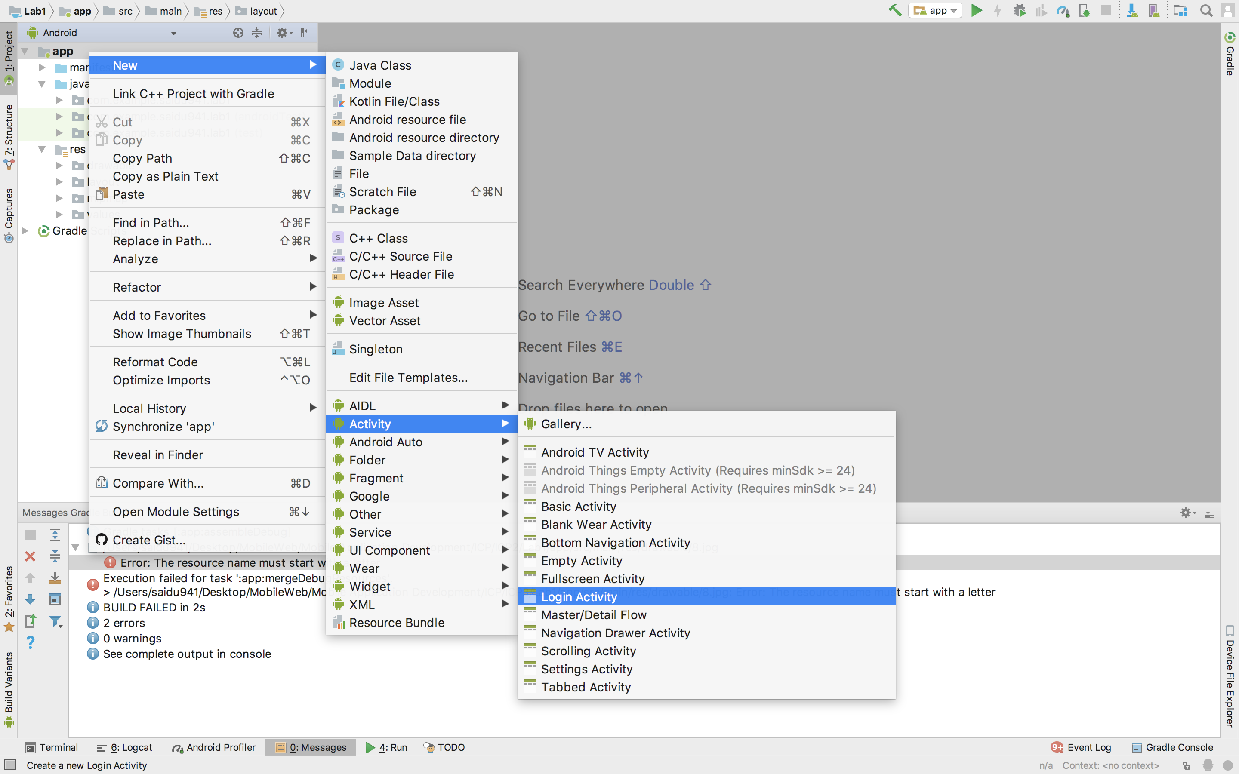

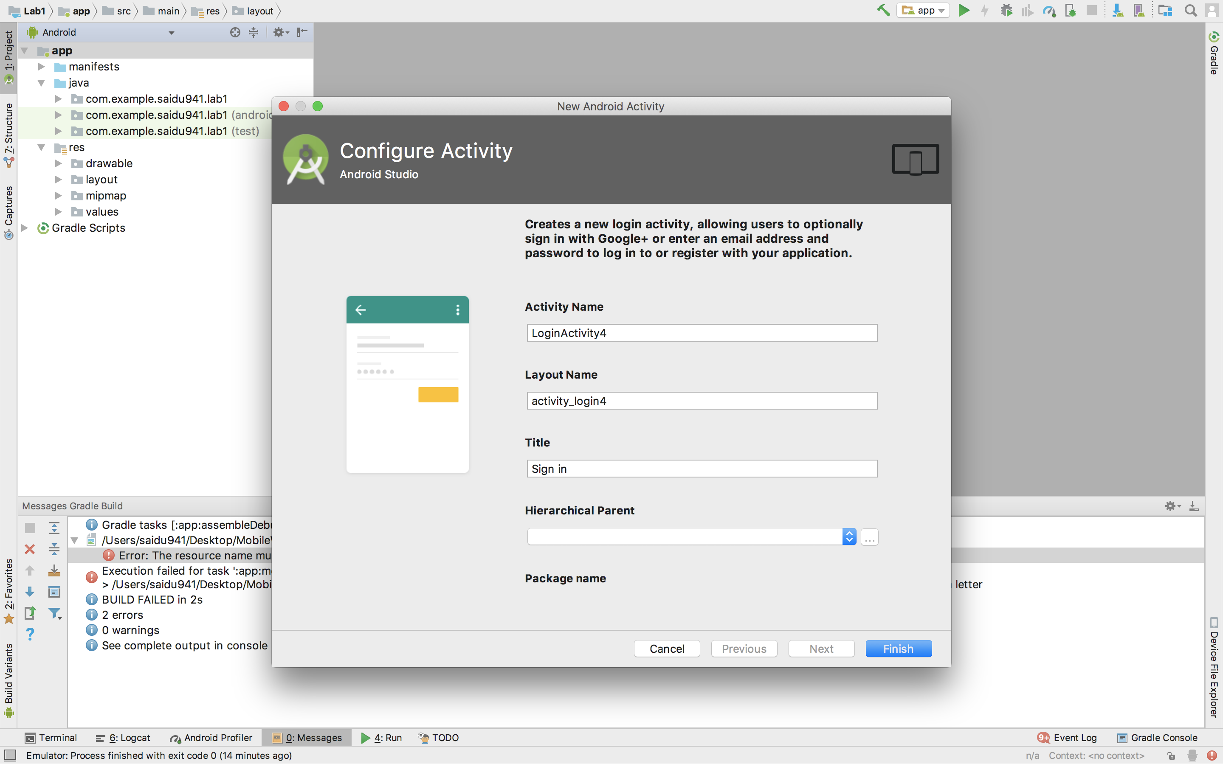

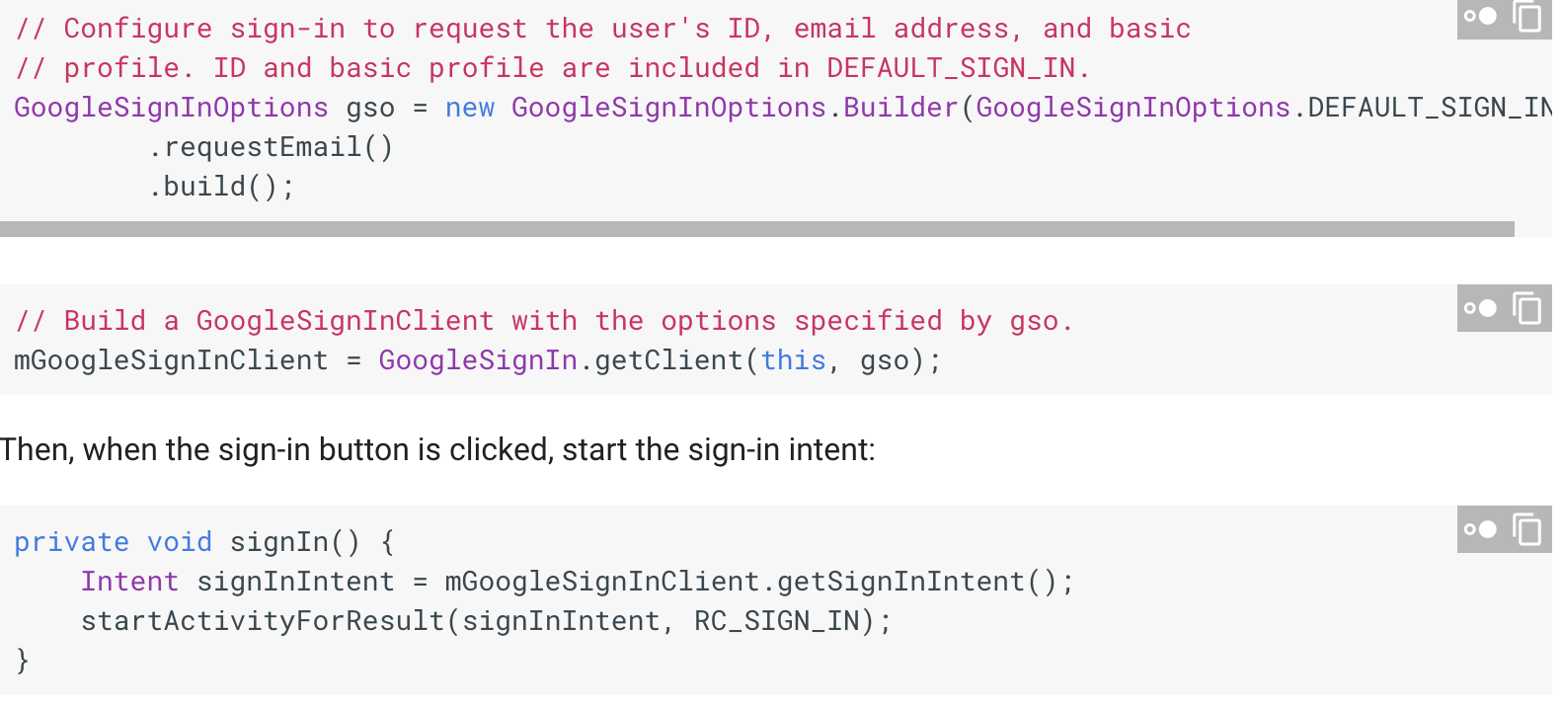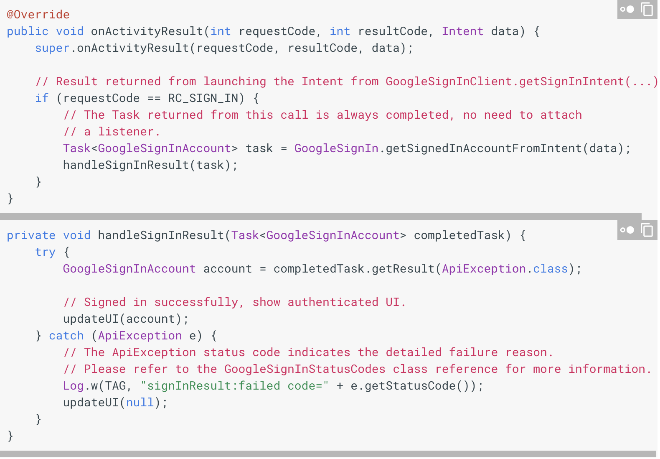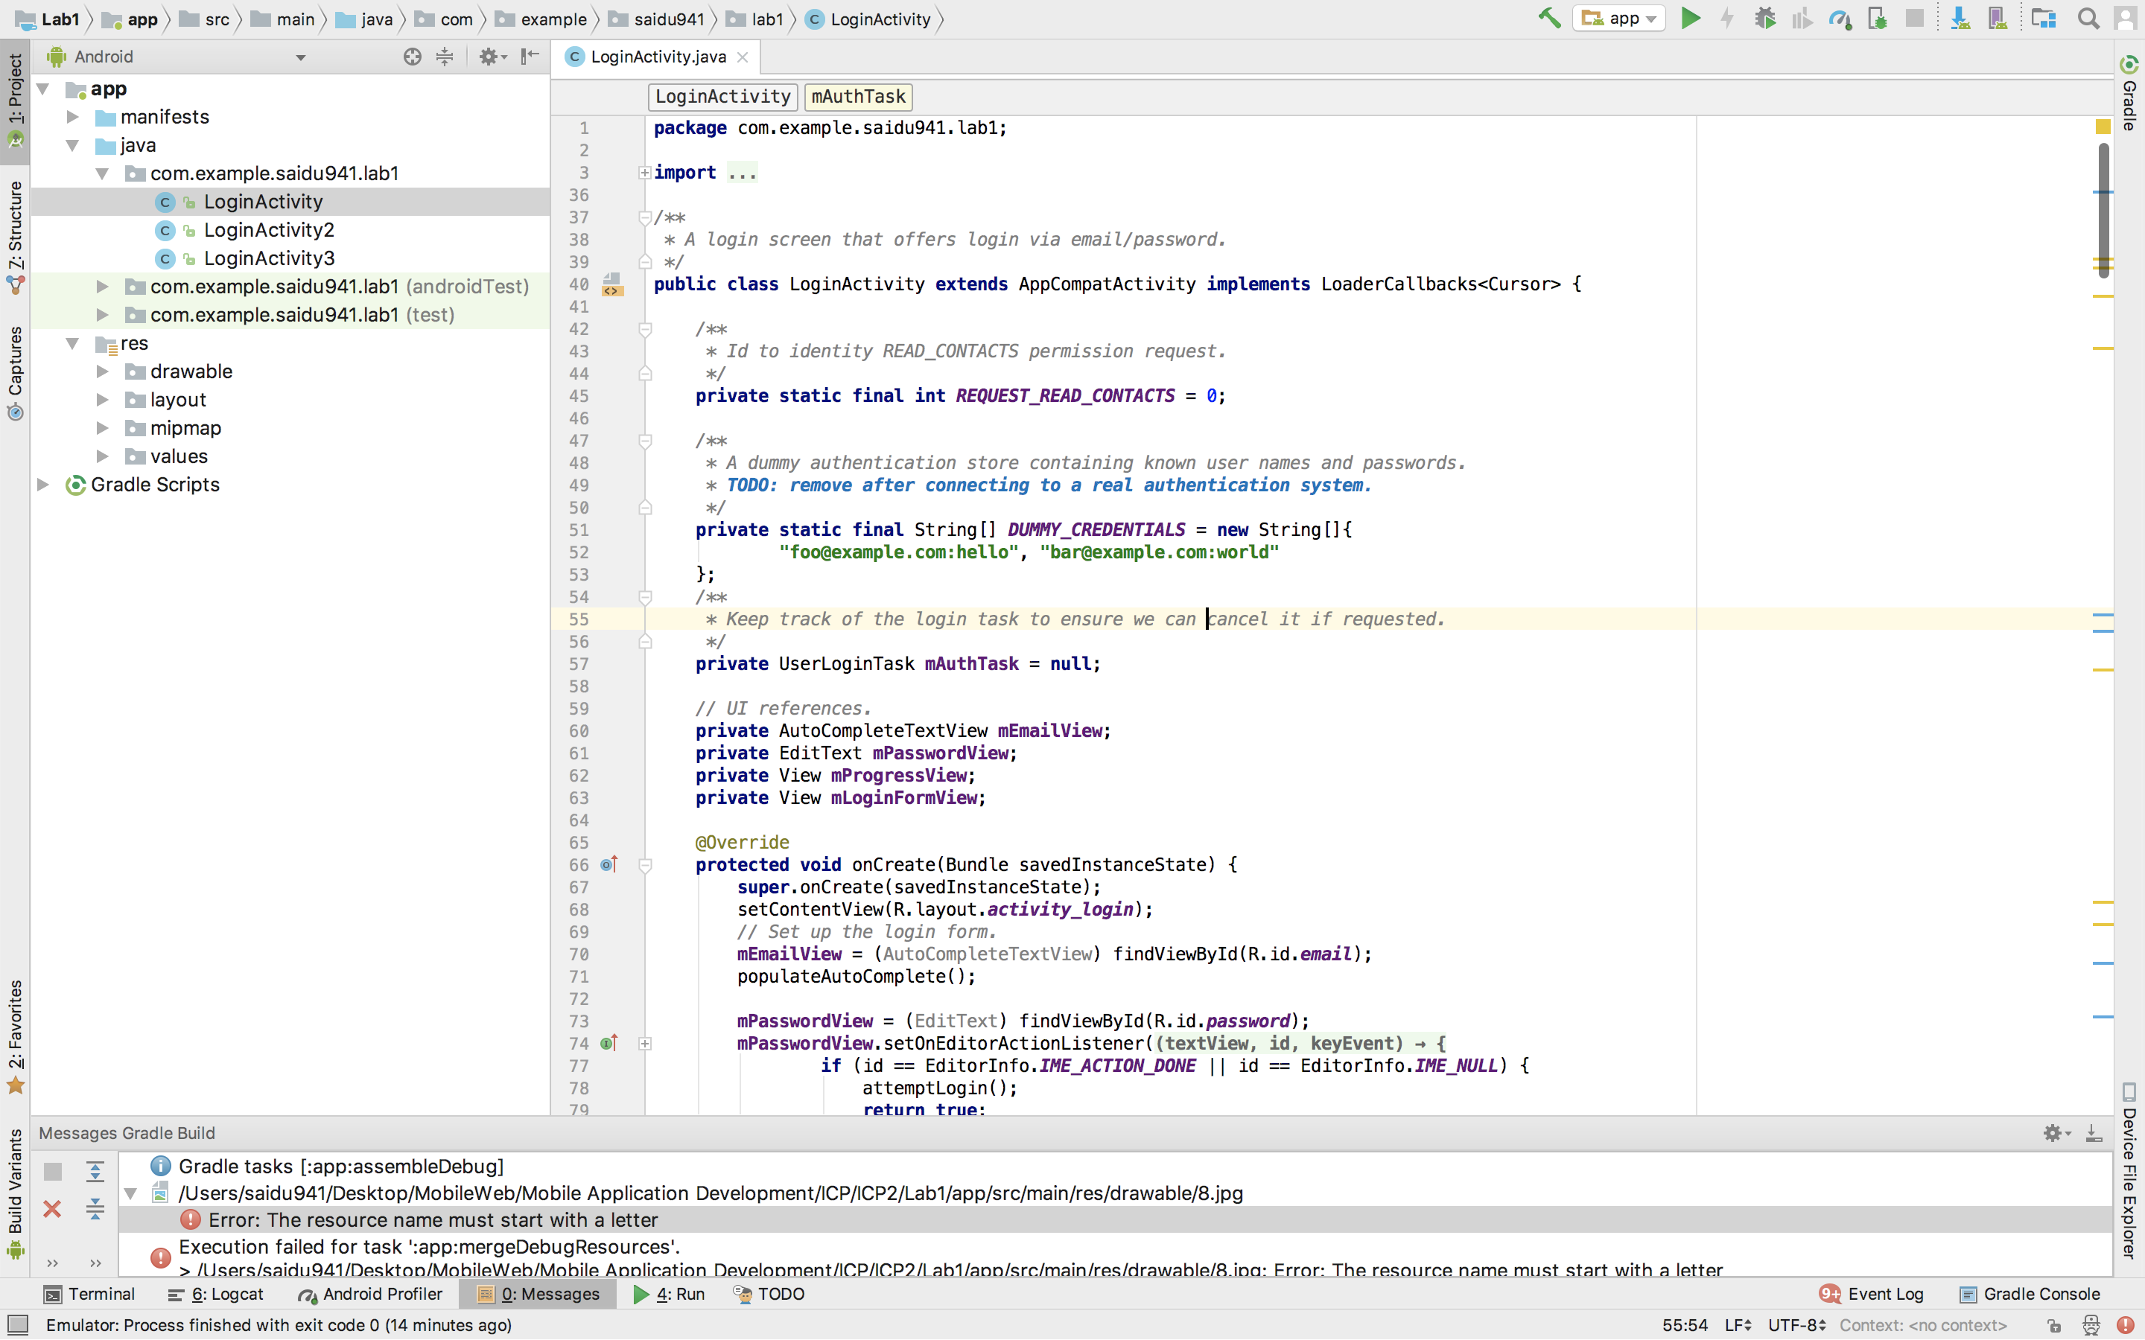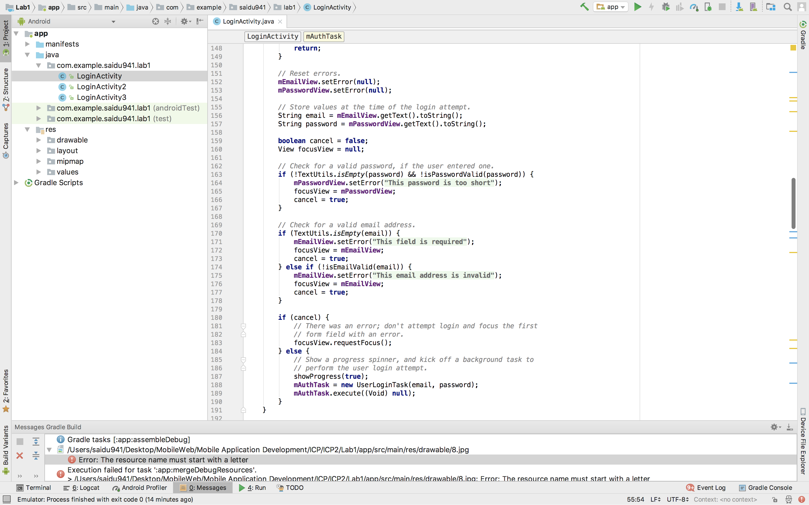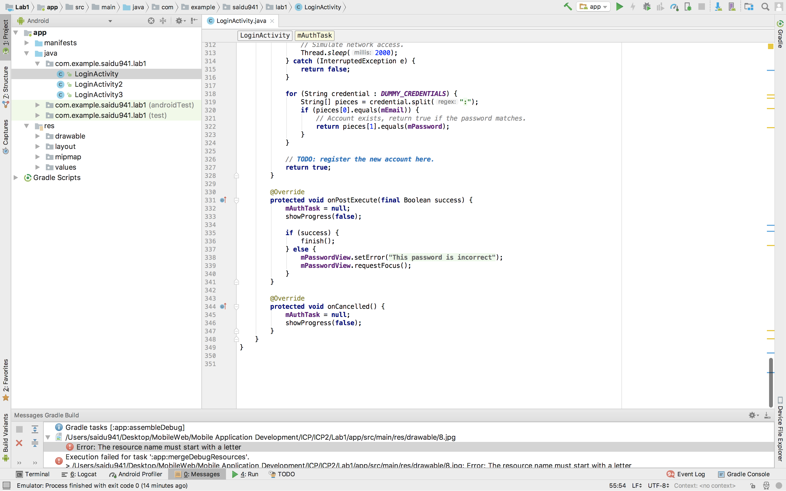

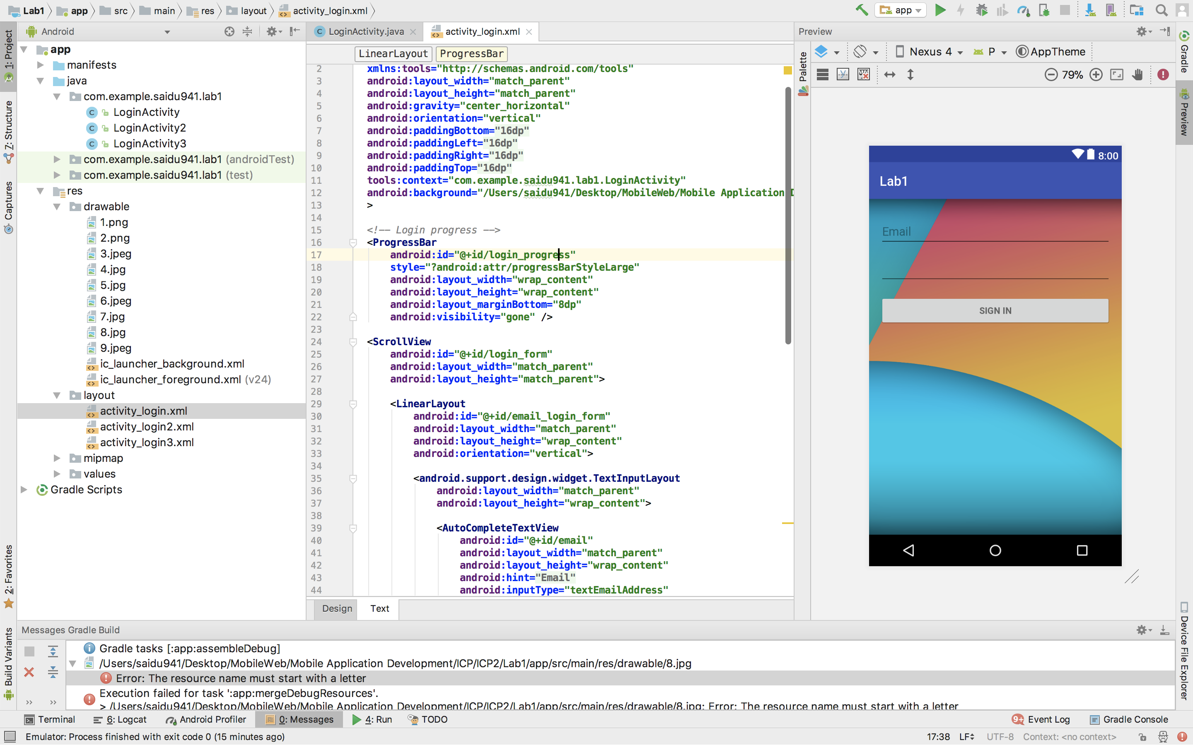

**Execution screenshots:**

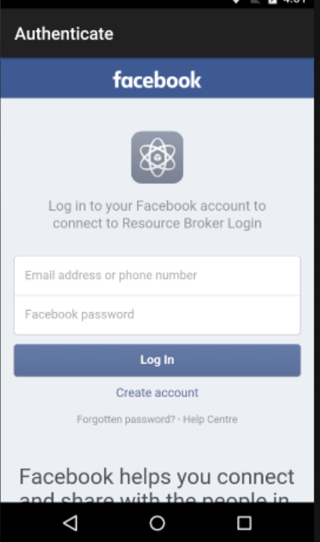

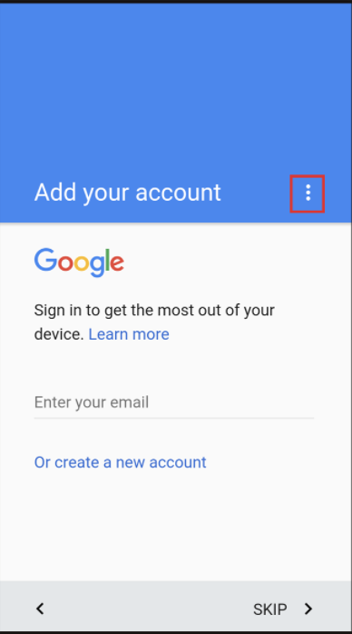

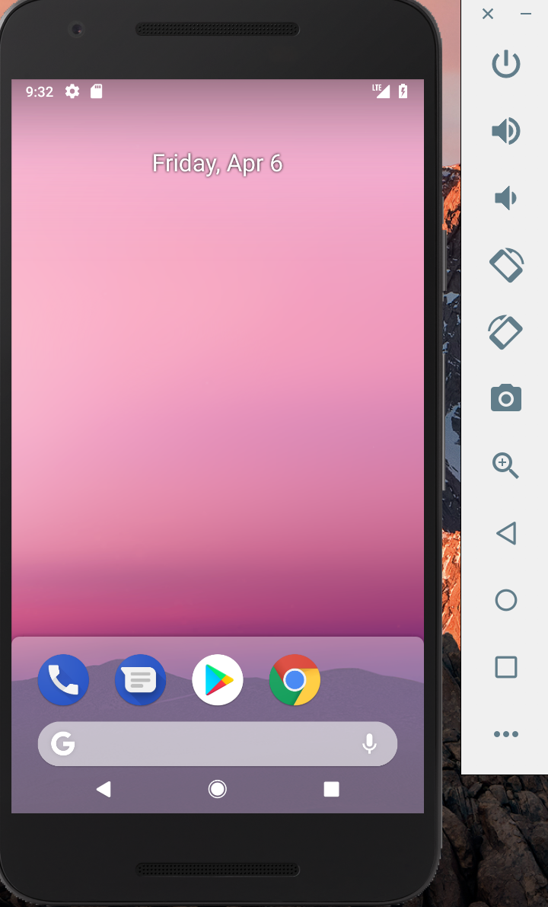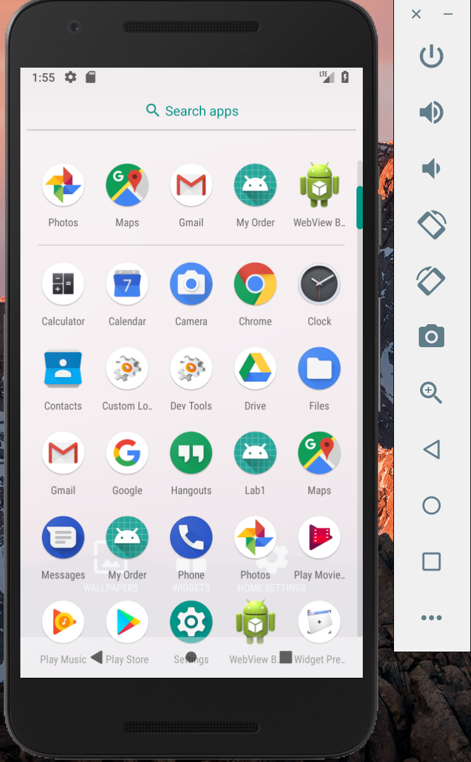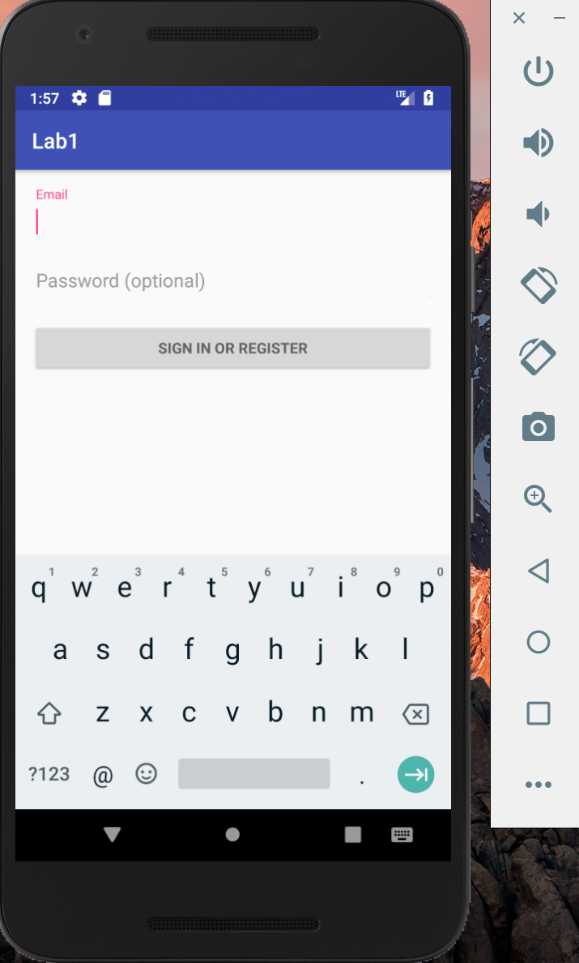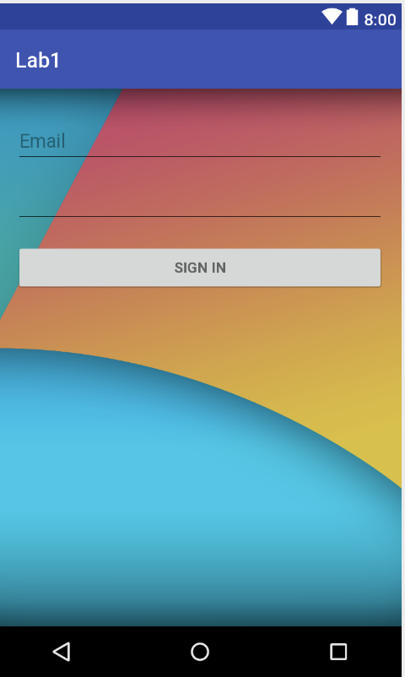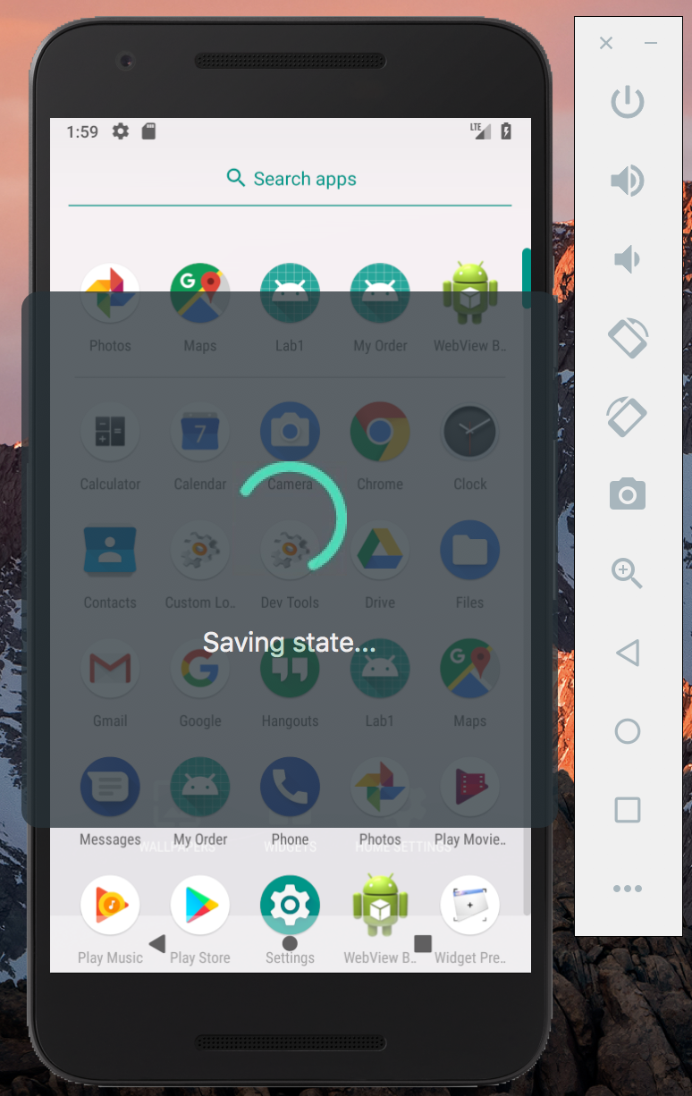

**Result & Conclusion:**

We have successfully created an application meeting the requirements

**References:**

<https://developers.google.com/identity/protocols/OAuth2> https://developers.facebook.com/docs/facebook-login/manually-build-a-login-flow